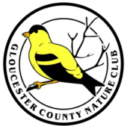
Gloucester County Nature Club
Monthly Newsletter
December 2025
www.gcnatureclub.org
Nature Club meetings are open to the public.

Directions: The Holy Nativity Lutheran Church is located just off Rt. 553 (Woodbury Glassboro Rd.) immediately south of the traffic light at Mantua Ave. The church parking lot can be accessed by entrances on either Woodbury-Glassboro Road or Lenape Trail (first left off of Mantua Ave).
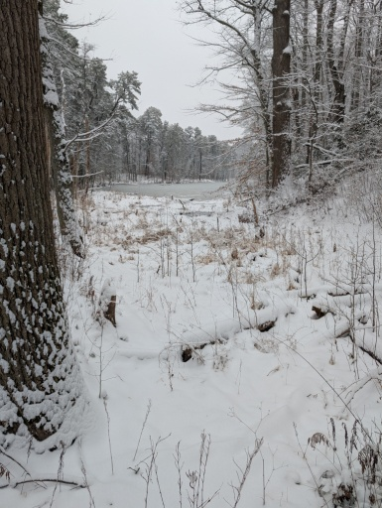
Program: The Evolution of Ceres Park, a Gloucester County Gem
Thursday, December 11th at 7:00 pm
Presenter: Erik Mollenhauer.
Many people have walked the trails of Ceres Park in Mantua, but few know the curious history of this local gem. Erik Mollenhauer will share the storied past of a land where dinosaurs roamed. This land would become a hustling industrial site and eventually reborn as a refuge for native plants and wildlife. In addition to the evolution of the park, the presentation will also feature some of the park’s native plants and the threats they are facing.

Tour de Natural Places:
December 16, 2025, Tuesday, 9am: Hidden Acres Township Park and Mantua Creek WMA. East Greenwich Twp. Hidden Acres has been re-named Samuel Giordano Sr. Memorial Football Field. Enter at the sign “Football Complex”. Follow the one-way signs all the way to the back of the gravel parking lot. Trail could be wet. Wear boots or old sneakers. Hosts: Sue Bergmann, Marilyn Henry. For more information, see Natural Places of Gloucester County, see pages 51-53, Location #13. Next we will drive or carpool a short distance to Mantua Creek WMA, pages 31-32, Location #7.We will be walking in grass which could be tall.

NW Gloucester County Christmas Bird Count – December 20th

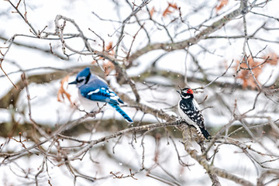
It’s the most wonderful time of the year! (Holiday time too!) We will be conducting the Gloucester County Christmas Bird Count through the National Audubon Society on Saturday, December 20. Once again we will be out there in the weather (good healthy air) looking and listening for birds to contribute to the National count. Our circle covers very interesting territory in the county and very interesting winter birds. We usually see a total close to 100 species! The ‘circle’ is broken down into 13 areas and each area has a leader who knows birds, the territory, and can navigate through the zone. This is a great, fun way to get out with others and learn from the many excellent birders we have in the club. No experience is necessary. All help is appreciated. If you would like to join us to see the very same birds you see in your yard and maybe many more you can add to your life list, then bundle up, pack a lunch, bring your binoculars and your enthusiasm! Some participants spend the entire day, others put in a couple of hours- whatever time they can afford to do. Times to meet and be out in the area can be worked out with your leader. Even if you do not go out with a team your observations of the birds in your yard, dawn to dark, are valuable and can be counted as part of our results for our NW Gloucester County circle. Here’s to a safe, productive (good weather!) count this year! To get hooked up with a team or if you have questions, call or email: Ron Kegel, compiler 609-617-0365 (cell); ronaldk52@comcast.net.


YOUTUBE CHANNEL: We are continuing to post recordings of recent club programs for the convenience of members and the public. To find the club’s channel, use this link or search for the club’s full name within YouTube. 33 videos are now available, including these recent additions:
- Red Bank Battlefield: An Unknown Story, An Opportunity (October 2025).
- Bears in New Jersey (November 2025 -- video to be released on or before December 6th).



